|  |  |  |  |  |  |
| --- | --- | --- | --- | --- | --- |
| Date | 7-Dec-22 | | | Tester Name | Mohammad Yusuf |
| Environment | Penfax - Test | | | Login used |  |
| Operating System | Windows | Version: | Update: | | |
| Software Used | Select Software | Version: | Update: | | |
| Select Software | Version: | Update: | | |
| Release version |  | | | | |
| Title |  | | | | |
| Test Type | Regression | | | | |
| Test Scenario |  | | | | |
|  |  | | | | |
| Expected Results |  | | | | |
| Pass/Fail | Select | | | JIRA# | N/A |

Describe your steps with screenshots:

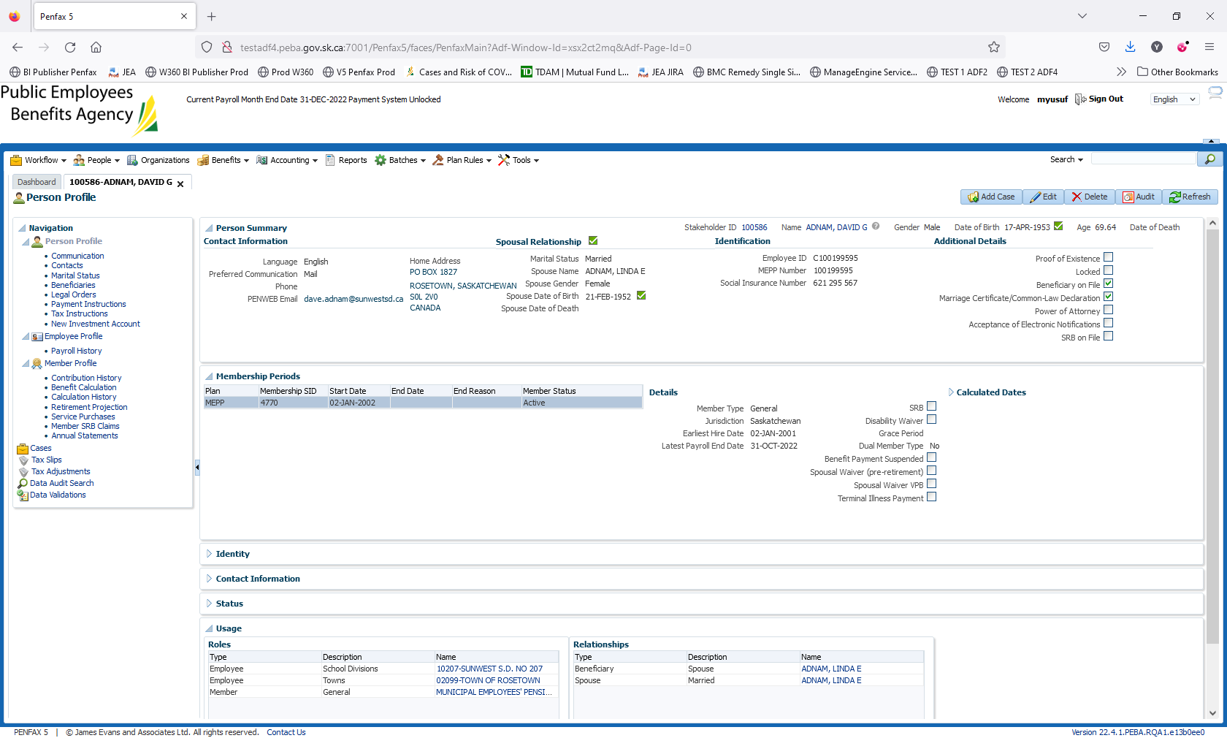

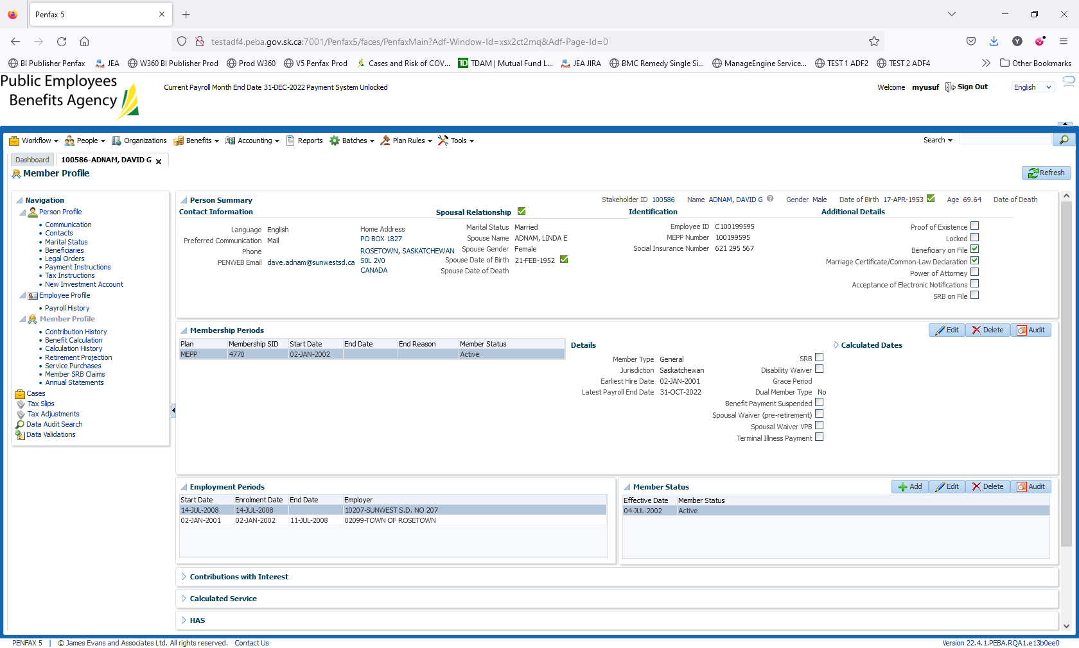

Navigate to Employee Profile -> Employment Periods. Click on edit on the existing Employer

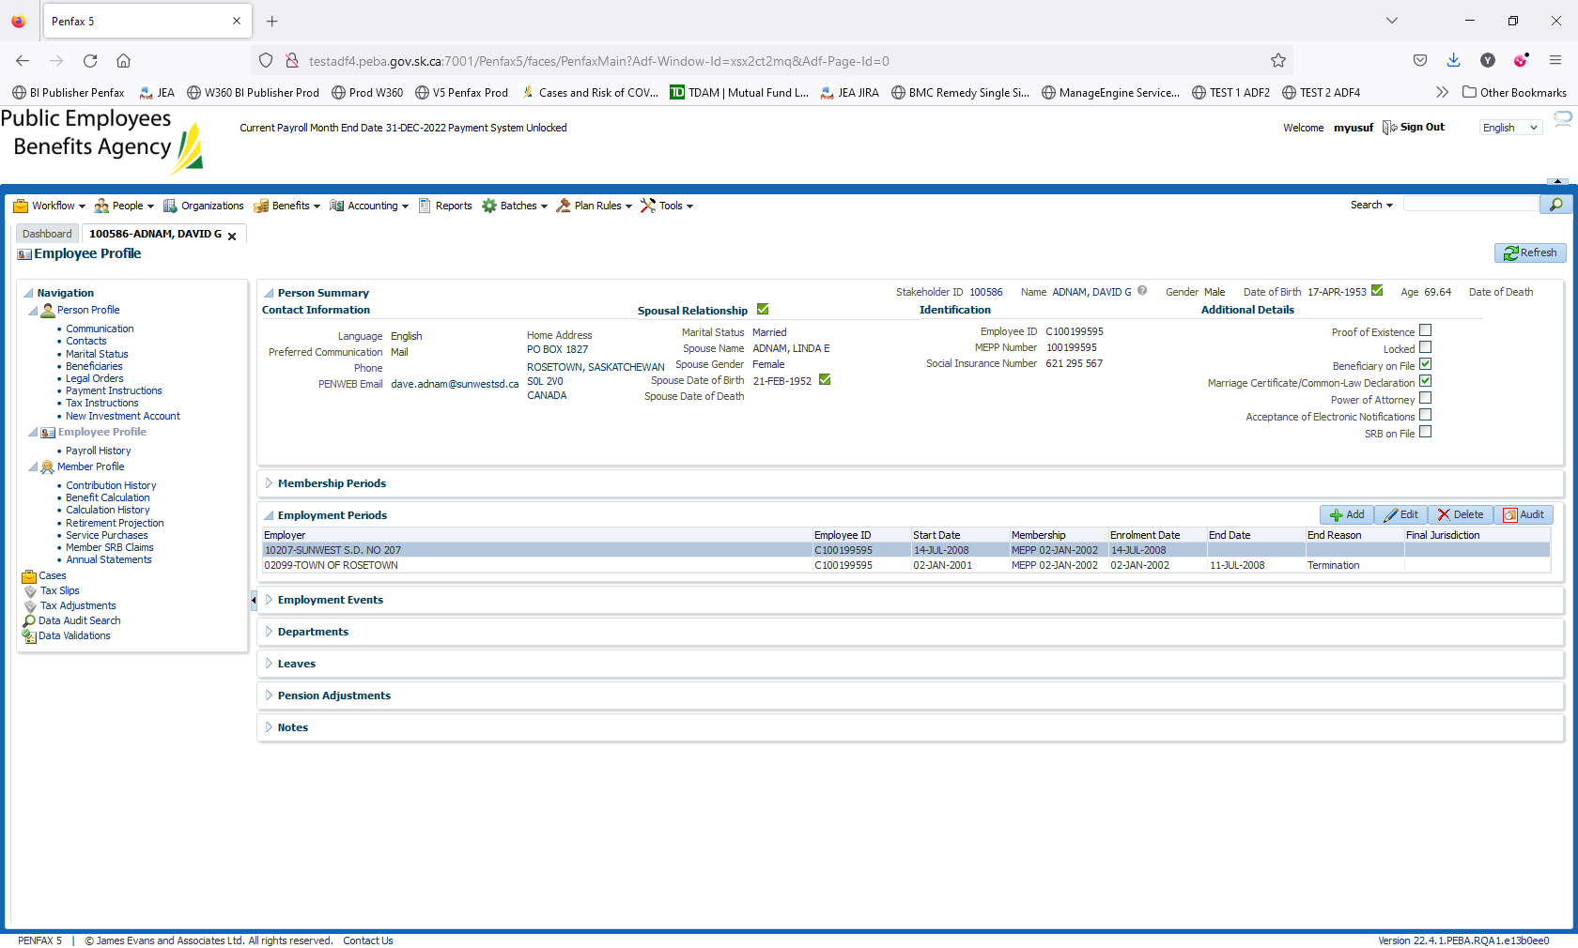

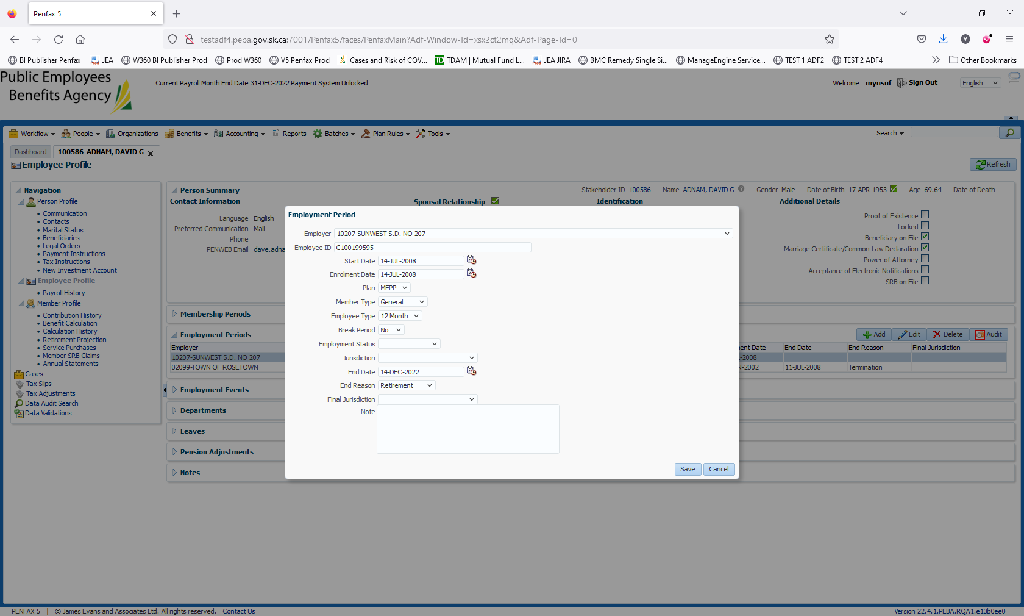

Enter the End Date and End Reason. Click on Save   
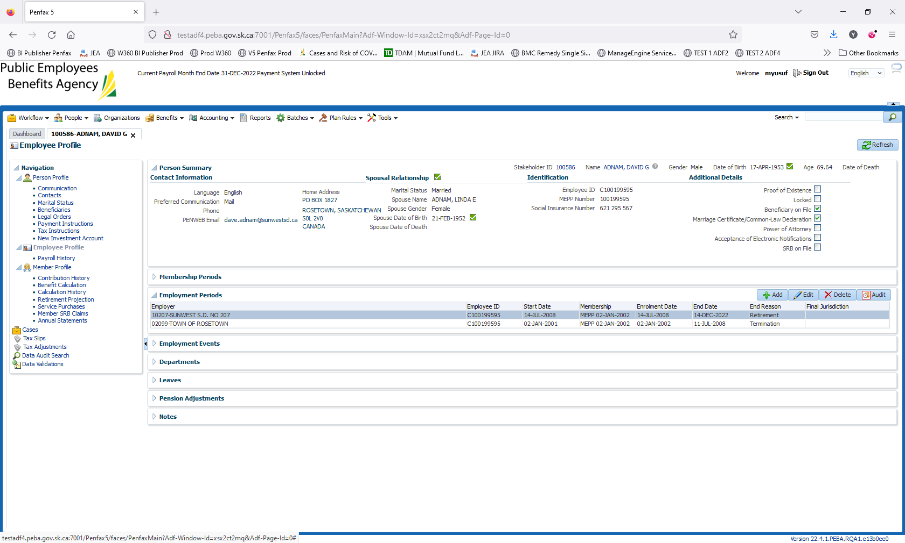

Go to Benefit Calculation. 1st of the next month is already input as the Retirement Date.

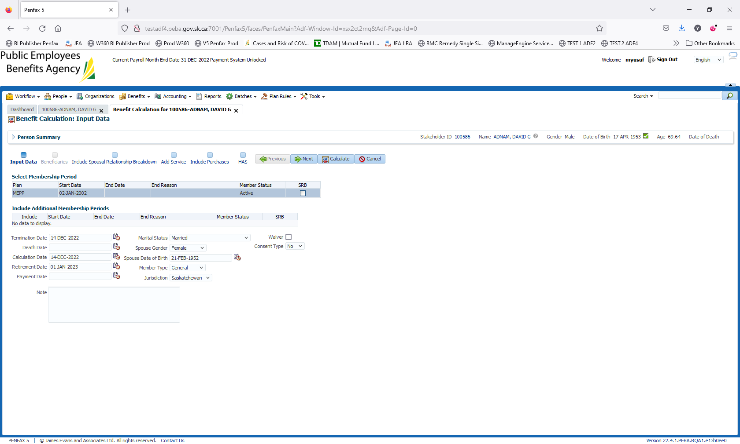

Click on Calculate. Select the option desired by the member. In our scenario, we will be selectinh 60% 5 option.

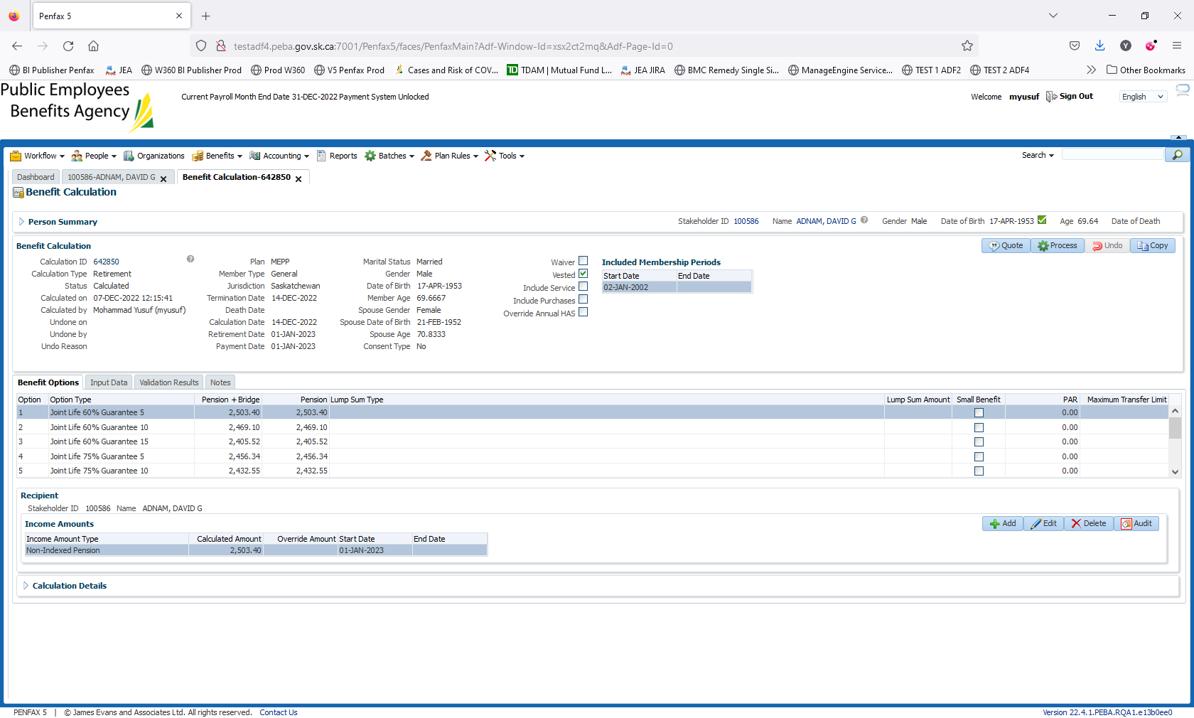

Click on Process

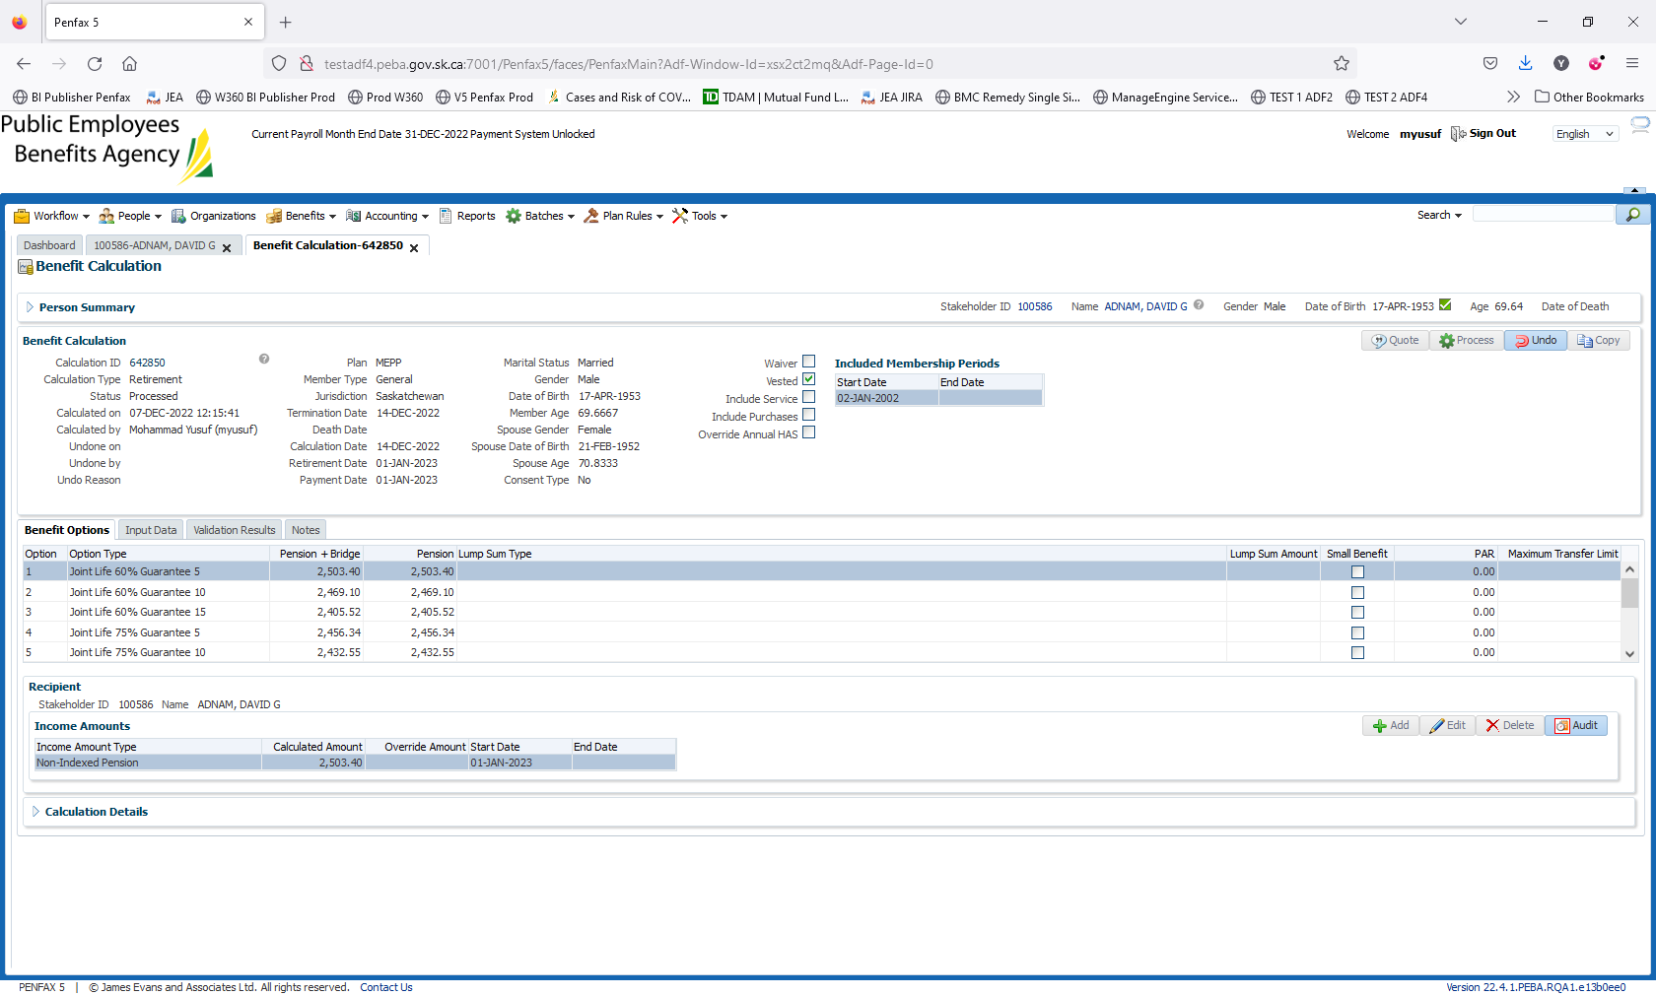

Go to Benefit Selection -> click on Next

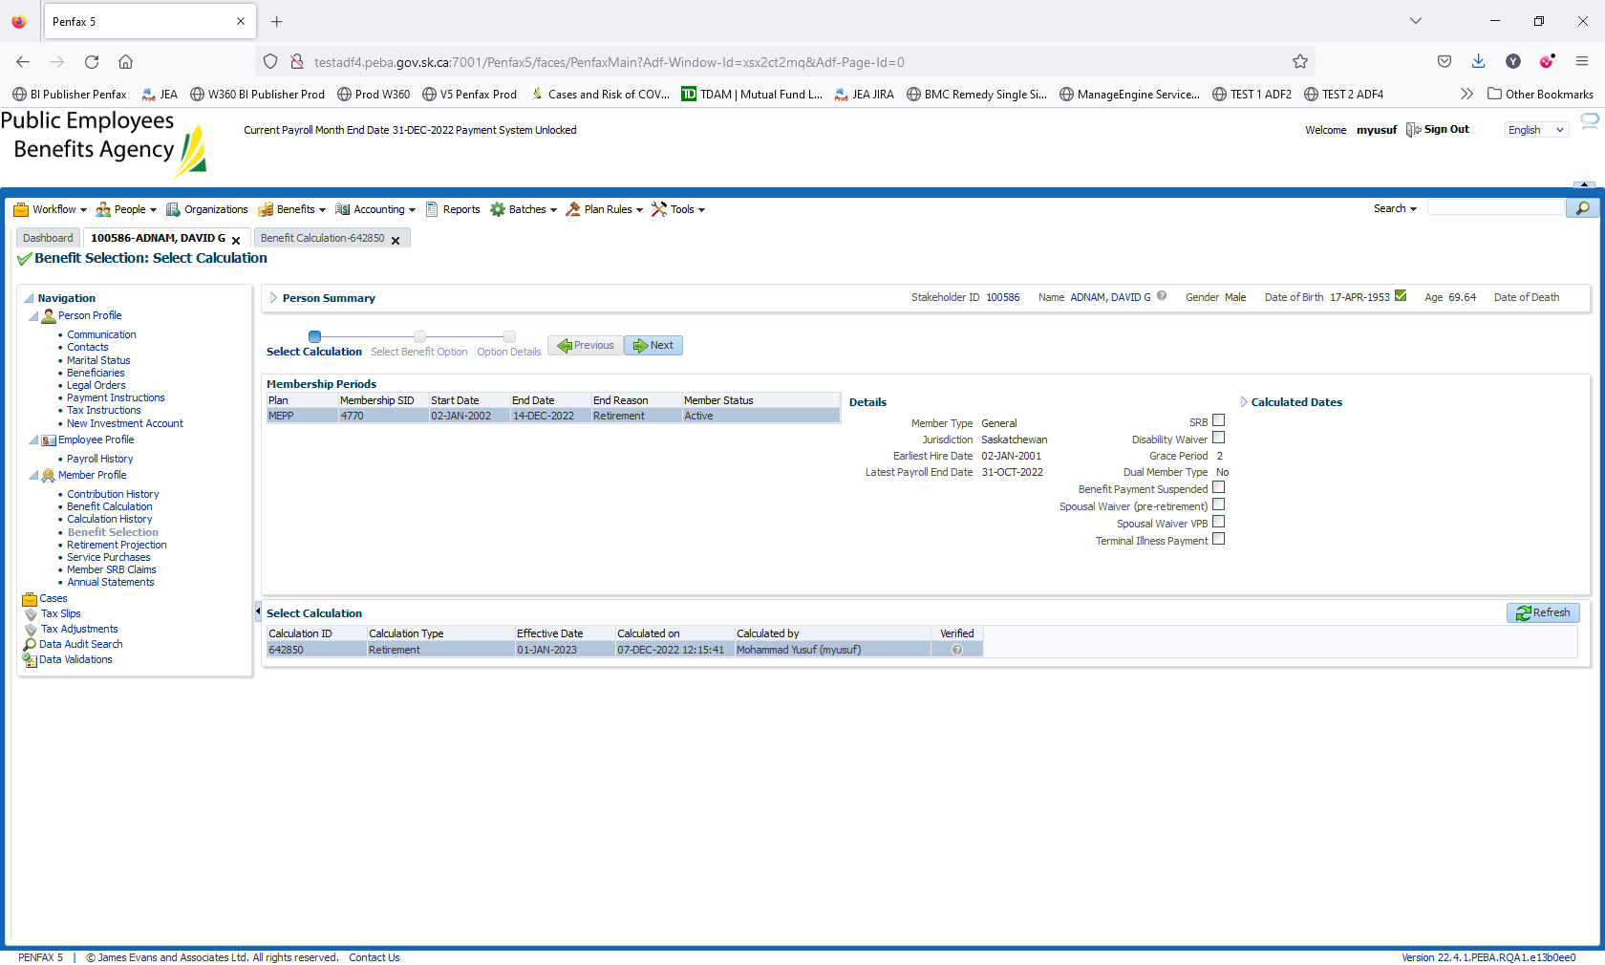

Click on Process. Enter the payment date as of Dec 30, 2022. As some tester has already run Dec payroll.

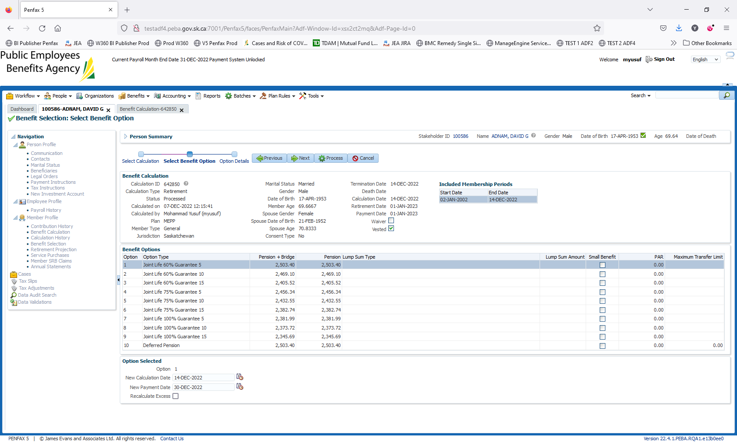

Retirement/Payment has been processed as 1st of the month. Then, authorize the payment

Later Navigate to income benefit to see the payment for retirement.